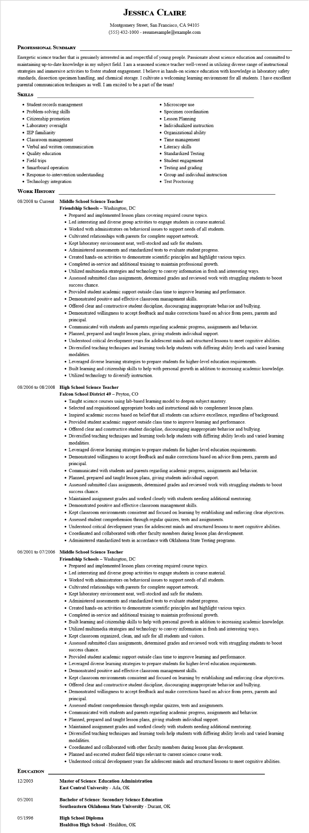
JESSICA CLAIRE
Montgomery Street, San Francisco, CA 94105 (555) 432-1000 - resumesample@example.com
PROFESSIONAL SUMMARY
Energetic science teacher that is genuinely interested in and respectful of young people. Passionate about science education and committed to maintaining up-to-date knowledge in my subject field. I am a seasoned science teacher well-versed in utilizing diverse range of instructional strategies and immersive activities to foster student engagement. I believe in hands-on science education with knowledge in laboratory safety standards, dissection specimen handling, and chemical storage. I cultivate a welcoming learning environment for all students. I have excellent parental communication techniques as well. I am excited to be a part of the team!
SKILLS
• Student records management
• Problem-solving skills
• Citizenship promotion
• Laboratory oversight
• IEP familiarity
⚫ Classroom management
• Verbal and written communication
• Quality education
• Field trips
• Smartboard operation
• Response-to-intervention understanding
• Technology integration
WORK HISTORY
08/2008 to Current Middle School Science Teacher
Friendship Schools - Washington, DC
• Microscope use
•
Specimen coordination
• Lesson Planning
• Individualized instruction
Organizational ability
• Time management
• Literacy skills
• Standardized Testing
• Student engagement
• Testing and grading
• Group and individual instruction • Test Proctoring
• Prepared and implemented lesson plans covering required course topics.
• Led interesting and diverse group activities to engage students in course material.
• Worked with administrators on behavioral issues to support needs of all students.
• Cultivated relationships with parents for complete support network.
• Kept laboratory environment neat, well-stocked and safe for students.
• Administered assessments and standardized tests to evaluate student progress.
• Created hands-on activities to demonstrate scientific principles and highlight various topics.
• Completed in-service and additional training to maintain professional growth.
• Utilized multimedia strategies and technology to convey information in fresh and interesting ways.
• Assessed submitted class assignments, determined grades and reviewed work with struggling students to boost success chance.
• Provided student academic support outside class time to improve learning and performance.
• Demonstrated positive and effective classroom management skills.
• Offered clear and constructive student discipline, discouraging inappropriate behavior and bullying.
• Demonstrated willingness to accept feedback and make corrections based on advice from peers, parents and principal
• Communicated with students and parents regarding academic progress, assignments and behavior.
• Planned, prepared and taught lesson plans, giving students individual support.
• Understood critical development years for adolescent minds and structured lessons to meet cognitive abilities.
• Diversified teaching techniques and learning tools help students with differing ability levels and varied learning modalities.
• Leveraged diverse learning strategies to prepare students for higher-level education requirements.
• Built learning and citizenship skills to help with personal growth in addition to increasing academic knowledge. • Utilized technology to diversify instruction.
08/2006 to 08/2008 High School Science Teacher
Falcon School District 49 - Peyton, CO
• Taught science courses using lab-based learning model to deepen subject mastery.
• Selected and requisitioned appropriate books and instructional aids to complement lesson plans.
• Inspired academic success based on belief that all students can achieve excellence, regardless of background.
• Provided student academic support outside class time to improve learning and performance.
• Offered clear and constructive student discipline, discouraging inappropriate behavior and bullying.
• Diversified teaching techniques and learning tools help students with differing ability levels and varied learning modalities.
• Leveraged diverse learning strategies to prepare students for higher-level education requirements.
• Demonstrated willingness to accept feedback and make corrections based on advice from peers, parents and principal.
• Communicated with students and parents regarding academic progress, assignments and behavior.
• Planned, prepared and taught lesson plans, giving students individual support.
• Assessed submitted class assignments, determined grades and reviewed work with struggling students to boost success chance.
• Maintained assignment grades and worked closely with students needing additional mentoring.
• Demonstrated positive and effective classroom management skills.
• Kept classroom environments consistent and focused on learning by establishing and enforcing clear objectives.
• Assessed student comprehension through regular quizzes, tests and assignments.
• Understood critical development years for adolescent minds and structured lessons to meet cognitive abilities.
• Coordinated and collaborated with other faculty members during lesson plan development.
• Administered standardized tests in accordance with Oklahoma State Testing programs.
06/2001 to 07/2006 Middle School Science Teacher
Friendship Schools - Washington, DC
• Prepared and implemented lesson plans covering required course topics.
• Led interesting and diverse group activities to engage students in course material.
• Worked with administrators on behavioral issues to support needs of all students.
• Cultivated relationships with parents for complete support network.
• Kept laboratory environment neat, well-stocked and safe for students.
• Administered assessments and standardized tests to evaluate student progress.
• Created hands-on activities to demonstrate scientific principles and highlight various topics.
• Completed in-service and additional training to maintain professional growth.
• Built learning and citizenship skills to help with personal growth in addition to increasing academic knowledge.
• Utilized multimedia strategies and technology to convey information in fresh and interesting ways.
• Kept classroom organized, clean, and safe for all students and visitors.
• Assessed submitted class assignments, determined grades and reviewed work with struggling students to boost success chance.
• Provided student academic support outside class time to improve learning and performance.
• Leveraged diverse learning strategies to prepare students for higher-level education requirements.
• Demonstrated positive and effective classroom management skills.
• Kept classroom environments consistent and focused on learning by establishing and enforcing clear objectives.
• Offered clear and constructive student discipline, discouraging inappropriate behavior and bullying.
• Demonstrated willingness to accept feedback and make corrections based on advice from peers, parents and principal.
• Assessed student comprehension through regular quizzes, tests and assignments.
• Communicated with students and parents regarding academic progress, assignments and behavior.
• Planned, prepared and taught lesson plans, giving students individual support.
• Maintained assignment grades and worked closely with students needing additional mentoring.
• Diversified teaching techniques and learning tools help students with differing ability levels and varied learning modalities.
• Coordinated and collaborated with other faculty members during lesson plan development.
• Planned and escorted student field trips relevant to current science course work.
• Understood critical development years for adolescent minds and structured lessons to meet cognitive abilities.
EDUCATION
12/2003
05/2001
Master of Science: Education Administration
East Central University - Ada, OK
Bachelor of Science: Secondary Science Education
Southeastern Oklahoma State University - Durant, OK
05/1996
High School Diploma
Healdton High School - Healdton, OK

